Chapter 3: Envelope and Drone Frame Design

# Mini Abstract

In this Chapter we first discuss our systems envelope and frame, the specifications they were designed to meet, and the reasoning behind those specifications. Then, the fabrication process of each of these parts will be discussed. Lastly, the process of verifying these parts and the results of the verification will be analysed.

# 

# Chapter 3 Draft

In this chapter we discuss each of the major mechanical subsystems of the Barone’s envelope and frame, the specifications they were designed to meet, and the reasoning behind those specifications. We will then be discussing the fabrication process and verification of each of these parts, with a full analysis of the verification results.

## 3.1 Barone’s Mechanical System.

The mechanical parts in The Barone can be separated into four distinct subsystems: the Ultrasonic array, Propulsion System, Gondola, and Envelope. Certain systems had specific subsystem or comment level requirements that had to be considered related to the goals of that subsystem. Additionally STR 2.0.0, Weight had to be considered for all subsystems as well as STR 11.0.0, Manufacturability. In this section the specifications and design choices for each of the subsystems will be explored.

3.1.1 Ultrasonic Array

The first subsystem is the ultrasonic array. This subsystem aimed to help satisfy the STR 4.2.1, Terrain Tracking. The ultrasonic mount holds three ultrasonic sensors on the front of the drone to provide our control system with information about the distance of obstacles in front and below the drone. For more information about our sensor array see Chapter 5 or for more information about the controls system see Chapter 6.

First, since the ultrasonic mount needed to hold 3 uniquely shaped objects on the curve of our envelope, it was decided that the part would be designed to be 3D printed in order to meet STR 11.0.0, Manufacturability. We decided that two ultrasonic sensors would face forward to assist with collision detection in front of the drone. The third ultrasonic sensor would be angled downward to look for obstacles in front of the drone that are below the line of sight of the two above to help with maintaining a stable height as well as obstacle avoidance. In order to best utilize the 15° field of view of the ultrasonic sensors. The two forward facing ultrasonic sensors were angled 7.5° in opposite directions so their field of views would not have overlap and we would be able to effectively double our forward facing field of view from 15° to 30°. The center ultrasonic sensor was angled downward at 45° so that its field of view would overlap with the ground while still looking forward. Each ultrasonic sensor was given its own 46x22mm(size of the ultrasonic sensor) mounting surface on the 3-D printed part which provided mounting holes for the sensors to be attached. The surfaces also had a cut out so that the soldered chips on the back of the ultrasonics would not be damaged. Finally the back of the part was given a curve to match that of the 54” radius of the envelope. A thin plate with the same height, width and curve was also printed that would be placed inside the envelope to help hold the part though . The ultrasonic sensor array is depicted in Figures 3.1 and 3.2.

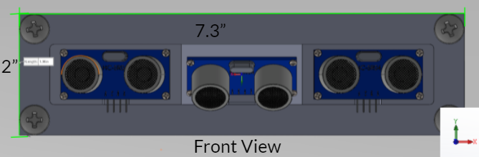

Fig. 3.1. Ultrasonic Array Front View

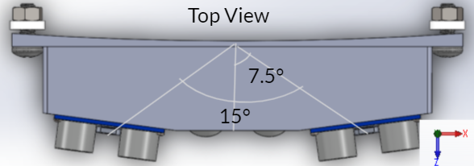

Fig. 3.2. Ultrasonic Array Top View

3.1.2 Propulsion System

The next subsystem is the propulsion system. This subsystem's goal was to hold the propulsion module discussed in Chapter 2 in order to fulfill STR 3.0.0, Remote Control and 4.0.0, Autonomous. To learn more about the actuators in the module see Chapter 4. For more information about the controls system see Chapter 6. The 4 propulsion modules would be placed equidistant from each other around the system so that the force they supply is balanced around the drone. The propellers need to be placed without posing a potential danger to the envelope.

Similar to the ultrasonic mount, the mounting block for the propulsion modules would be 3D printed in order to fit the shape of the servo as well as fit the curve of the 54” diameter envelope. To fit the servo into the mount, a hole was cut into the block shape with the exact dimensions of the servo, 20x40x30mm. The servo would be placed into this block and nuts screwed into holes placed to line up with the attachment bracket of the servo. Since the servo needed to be connected to the motor such that the servo’s axis of rotation would be perpendicular to the force axis of the propellers, a carbon steel shaft was attached to the servo using a 25T servo coupler. The 25T represents the 25 teeth the servo has on its rotation gear. The shaft itself was made to be 6” to avoid the 4.5” radius propeller from making contact with the envelope. At the end of the shaft a 3D printed mounting block was to be attached. This mounting block would be the size of the motor stand so that the motor would be able to be mounted to the block perpendicular to the servo shaft. Lastly, a mounting plate with the same dimensions of the bracket was printed to go inside of the envelope similar to the ultrasonic plate. This system is depicted in figure 3.3.

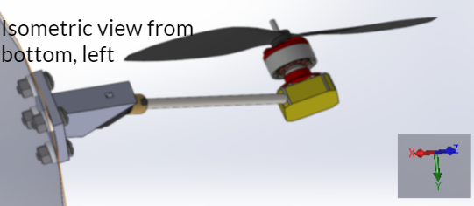

Fig. 3.3. CAD of Propulsion Subsystem

3.1.3 Gondola

The next subsystem is the gondola. This subsystem was designed to hold all the remaining onboard electronics needed for the drone that are not contained within other subsystems. The gondola can be broken into 3 distinct sections. The primary housing basket, the payload bay, and the outside attachments. Each of these subsystems were used to hold different electronic components. To learn more about the housed electronics see Chapter 5.

First, the primary housing basket, this section holds the battery, the voltage regulators, the ESCs, and the PCB used to house the sensors and microcontroller. The primary housing basket had holes added to the sides so that wires could be passed from the inside of the gondola to the propulsion system, external computer, or other electronics. The dimensions of the housing basket, 7x7x5”, were chosen in order to house all the necessary parts, the largest of which was the battery whose length of 6.8” defined the length and width requirements of the gondola. The bottom of the housing basket was made of a thin aluminum plate that the PCB, ESC, and switching regulators would be attached to with standoffs. An aluminium plate was chosen to help regulate any heat inside the gondola due to its high specific heat capacity compared to most medals.

The second section is the payload bay. This section was primarily designed to house the MagAero, the magnetometer used by the USGS to collect their data. Since the MagAero has a height and width of 50x150mm, the height and width of the payload bay were allocated extra room to be 53x158mm to allow the payload to be tied down or tethered to the payload bay. On the bottom of the payload was the final ultrasonic sensor of our system. One ultrasonic sensor was mounted directly to the bottom of the payload bay and extensions were added so that the gondola would rest on the extensions rather than the ultrasonic sensor. Since the extensions were also going to be 3D printed, the overall height of the whole system needs to be 7” or less in order to fit within the printer we had access to. In order to comply with STR 11.0.0, manufacturability, the 7” height limit leaves the payload bay and housing basket little room for error in the vertical dimension. The extensions were also designed to be printed separately so that they would not take away from the possible height of the gondola.

The final section of the gondola are the parts attached to the outside. This section includes the remote control transceiver, the camera, the voltage alarm, and the power switch. These parts all fit onto the sides of the housing basket with minimal modifications to the design. All of these parts were able to simply be attached to the side of the gondola with command strips. Going into the housing basket, wires are run to the power switch, remote control transceiver, and voltage alarm. The gondola with all attached sensors is illustrated in figure 3.4.

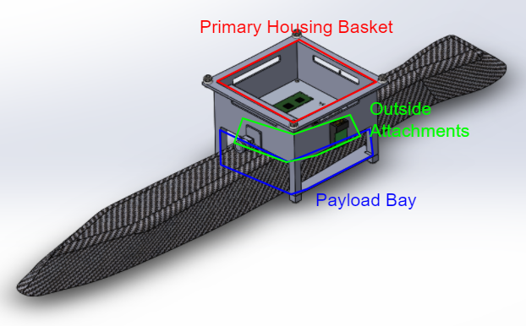

Fig. 3.4. Gondola CAD Housing all Electronic Components.

3.1.4 Envelope and Lift Bag

In order to meet STR 1.2.0, Weight, as well as STR 2.0.0, Drone Speed, the final subsystem designed was the envelope and lift bag.

After work began on the project it became clear that our drone would weigh about 45N without helium. The breakdown of this weight can be seen in our weight budget which can be found in the Chapter 15 appendix. To bring our weight down to the range specified in STR 1.2.0, Weight, we would need to add 4m3 of helium to apply 40N of buoyant force opposite gravity. Therefore 4m3 became the volume of Helium in the lift bag in order to prove the necessary buoyancy to meet STR 1.2.0, Weight.

In order to accomplish the STR 2.0.0, Drone Speed, we adjusted the shape of the envelope around the lift bag to be an ellipsoid. Using the drag equation introduced in Chapter 2, a basic drag analysis was done in MATLAB on ellipsoids of different sizes to find the drag our drone’s envelope would be experiencing. Based on the analysis shown in figure 3.5, it can be seen that by reducing the height of the envelope, horizontal drag would be reduced. We chose an ellipsoid which would experience 4.6N of drag force in 20 MPH forward airspeed. The reduction in drag would be accomplished by fitting a 108” diameter balloon inside a 108”x108”x40” envelope; these dimensions are as shown in figure 3.6. Additionally, 4.6N was chosen as it was the lowest drag achievable with the 108” Lift Bag and also less than the effective thrust of our propulsion system. To learn more about the propulsion system see Chapter 4. The envelope additionally functions as a surface to attach parts to the system without damaging the lift bag.

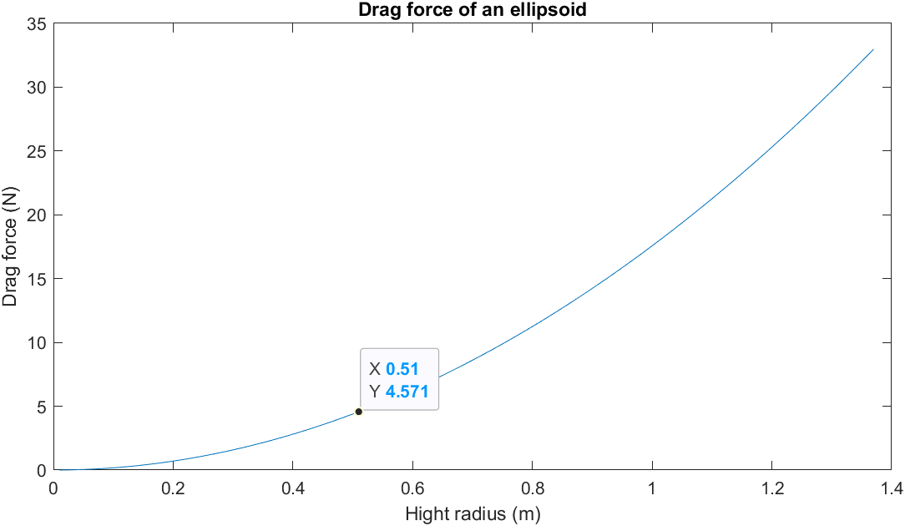

Fig. 3.5. Matlab Graph of Initial Drag Analysis on the Drone

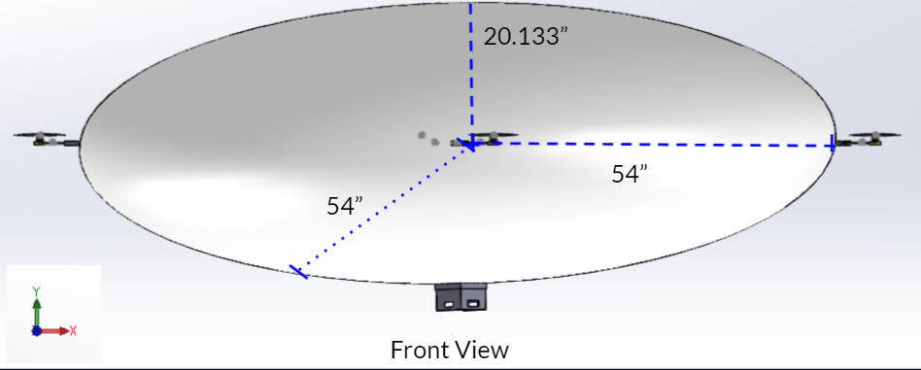

Fig. 3.6. Envelope CAD Design

Once the shape was decided, a material had to be chosen, this material needed to be able to withstand the largest forces applied to it from the attached parts. We found that the largest applied force to the envelope during a flight comes from the weight of the propulsion system falling after the motor turns off. For more information on the propulsion system see Chapter 4. Based on the force diagram in figure 3.7. The following equation was derived $F_{e}=F_{m}\frac{r_{s}}{r_{b}}sinθ^{2}$ (3.1)[16]. By plugging the maximums of our known values into equation 3.1 it was found that the worst case pressure applied to the envelope during flight would be 6.63psi. Once the maximum pressure value was known, a Pugh chart, as seen in figure 3.8, was created with various potential materials. 1.0 HyperD nylon was chosen as it could both withstand the worst-case pressure as well as maintain a low weight and price point to help meet STRs 1.2.0, Weight, and 5.0.0, Cost.

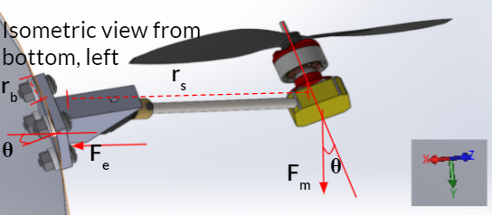

Fig. 3.7. Force Diagram of Propulsion System Applying Lever Force to Envelope

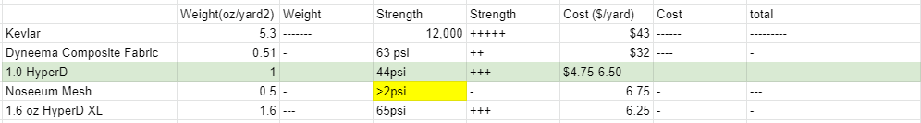

Fig. 3.8. Pugh Chart of Potential Envelope Materials

The HyperD nylon would be sewn together into the shape of the envelope using nylon string of similar material. As our tool of fabrication, the sewing machine was chosen, since it was something we had access to when fulfilling STR 11.0.0, Manufacturability.

## 3.2 Fabrication

This section will go over the fabrication process of the mechanical subsystems and will address the procedures, issues, and successes of the fabrication process. Additionally, before fabrication of the system was started, a CAD model was created with all subsystems designed to their stated specifications for both expected dimensions and weight. This can be seen in figure 3.9. This CAD was used to get early estimates for various force vectors used in various analyses, such as the forces fed into the control system, seen in Chapter 6, or the masses in the simulation, seen in Chapter 8. Once the CAD was finished, fabrication was ready to begin.

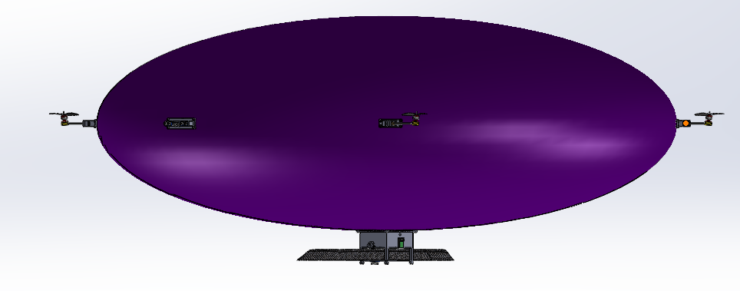Fig. 3.9. Full Barone CAD

3.2.1 3D Printing

Since the ultrasonic array, propulsion mount, and gondola were all decided to be 3D printed. The 3D printing process needed to meet STR 11.1.0, 3D Printing: All 3d printed components should fit within dimensions of the Lulzbot Taz4 or Lulzbot Miniprinter beds. These printers were specified in the requirements as they were the printers we had access to. A Pugh chart was created with 3D printing materials shown in figure 3.10 to decide on a material to use for 3D printing. We found that all of the materials were more than strong enough to withstand the forces that the system would be encountering. Nylon was ultimately chosen due to its high print accuracy and resistance to sun damage.



Fig. 3.10. 3D Printing Materials Pugh Chart

The process of 3D printing was riddled with errors. First the relevant CAD models for the mounting brackets and plates were converted to STL files and placed into 3D printing software, Cura Lulzbot edition. This was the software we used due to its compatibility with the printers we had access to. Originally we were using the Lulzbot Taz4, to print our parts. This printer had a large bed and was able to print all our parts in one piece. However, multiple problems arose in the process. First, the nozzle repeatedly clogged due to previous users using incompatible printing materials. Once the nozzle was cleared, we tried to print our first parts; however, the parts would repeatedly get knocked off of the printer bed or begin to curl half-way through a print. We later found out that the printing bed was not level. We tested the evenness of the bed by using the ‘paper test’, where the nozzle would move across the entire area of a printing bed without making contact with a single sheet of paper between the bed and nozzle. The ‘paper test’ showed that on some corners of the bed the nozzle did not make any contact with the paper, but on other corners the paper was dragged across the surface of the bed by the nozzle. The results of the ‘paper test’ confirmed that the bed was not level. Although many hours were spent trying to level the printer bed, The Taz4’s outdated manual leveling system, which had been broken at some point to our use of it, prevented us from fully leveling the bed with any further precision. Since we could not fix the unleveled bed a stronger glue was used to adhere the printed parts to the bed. With this quick fix,the majority of parts were printed on the Taz4, so the accuracy of the prints was not great, likely due to the unlevel bed and old nozzle. The ultrasonic mount, motor mounts, gondola, and all mounting plates were able to be printed. However only one of the propulsion mounts was able to be printed before the thermistor on the Taz4 hot end broke. This was confirmed by checking the resistance of the thermistor. At room temperature the thermuster should have a resistance of 90kΩ-110kΩ, when tested the resistance was found to be only 18Ω showing that it was broken, since we did not want to wait for a new hot end to arrive, the prints the remaining prints where done on a Lulzbot Mini that we had access too. Although the Lulzbot Mini’s bed was smaller, it had a self bed leveling feature and a much cleaner nozzle, which resulted in high print accuracy. The Lulzbot Mini was able to do the reminder prints without fail since the remaining parts to be printed were all small enough to fit onto its bed.

Despite many hardware bugs with the 3D printing process and low print accuracy on many of the parts, all parts were successfully able to be printed and we were able to move onto the verification process.

### 3.2.2 Envelope

The fabrication process of the envelope was one of the trickiest and most time consuming parts of this project. First, we needed to design a method to sew the fabric into the correct shape. This method needed to meet STR 11.3.0, Envelope. The envelope must be able to be cut with standard scissors and sewed with sewing machine Dylan owns, for dimensions to be within 5% of design when inflated. This was a difficult process as turning a 2D shape into a 3D one has many challenges. During research the process of goring was found. This is the process used to make globes out of many elliptical shapes. I was able to find out that the ellipse with our dimensions could be made with 12 gores each 122.5” tall and 28.5” wide. The curve of these gores would be the same as the curve of a 138.25” radius circle. These numbers were calculated using the trigonometry used in goring processes[18]. The dimensions of the gores are shown in figure 3.11.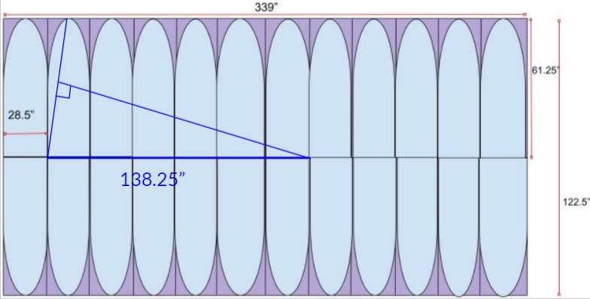

Fig. 3.11. Gore Dimensions for 108”x108”x40” Ellipsoid

Once the dimensions were found, pieces needed to be cut out from the 60'' tall roll of nylon. Since the sheet was only 60” tall, it was decided that 24 half gores of height 60” would be made rather than the 12 122.5” gores. The haves would then be attached together resulting in 12 120” full gores. The shorter height of the gores would result in a hole in both the top and bottom of the envelope. The hole on top would be patched using a fitted sheet of nylon and the hole on the bottom would be left in order to have access to the inside of the envelope for the purpose of attaching mounting plates and putting in the lift bag. Additionally an extra ¼” was left on either side of the sheets to account for loss of width in the sewing process. First,24 rectangular sheets were cut out. Then, a string of length 138.25” was used to trace the curve onto one of the sheets. This first sheet was used then cut out along the curves, and was then used as the trace for the rest of the sheets. The same trace was used for all the gores as to keep any error there may have been consistent. It would be better to have gores that are all wrong in the same way rather than gores with different errors. Once all 24 half gores were cut out 12 of the halves were sewn to the other 12. This resulted in 12 full gores that were the expected dimensions picture in figure 3.12.

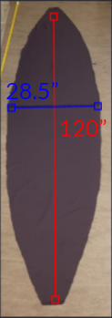

Fig. 3.12. One of 12 Gores.

Once all the gores were cut out the sewing process began. Since the team was inexperienced at sewing this part was riddled with mistakes. First it took many hours to figure out how to consistently properly thread the sewing machine. However, after many hours working with the machine multiple members of the team became proficient at threading the machine. The same was the case with the switch quality, although early on the quality of the stitches was questionable at best, resulting in uneven stitching. The quality of the stitches improved over the fabrication process. Once all twelve gores were sewn together the envelope seemed roughly the expected shape picture in figure 3.13. However the holes in the top and bottom were far bigger than expected. This error was thought to be caused by the poor stitch quality on some of the gores. Nevertheless the hole on the top was patched anyway and the envelope was ready to be tested.

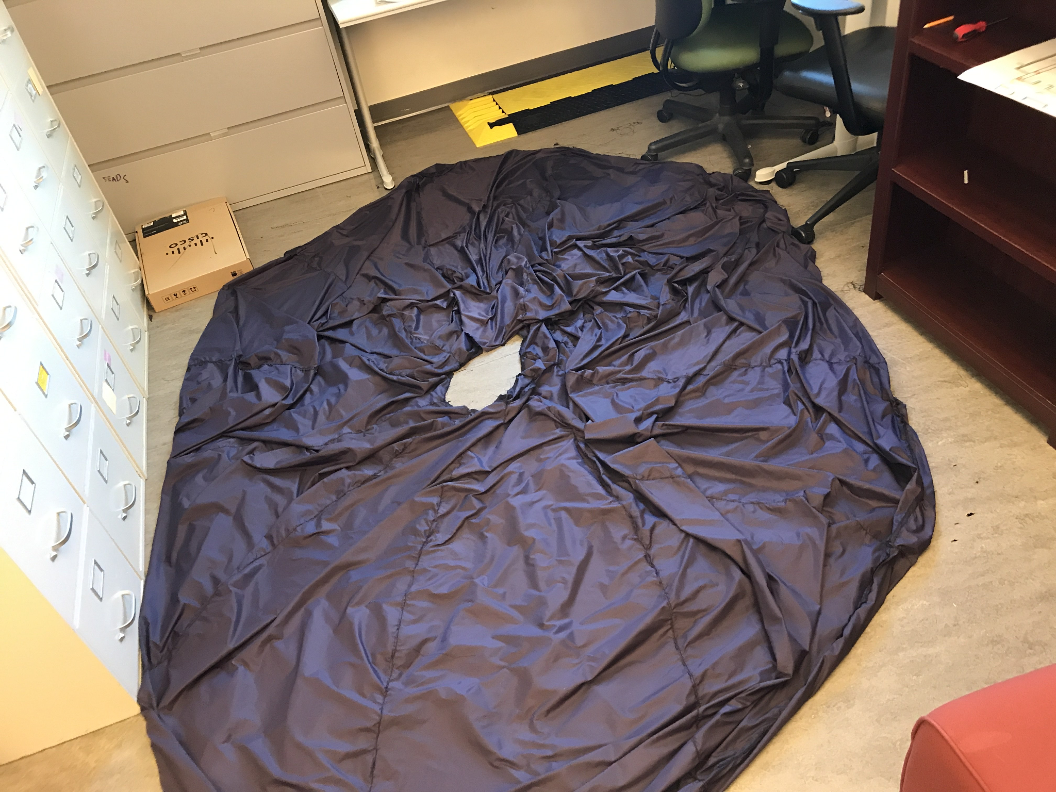

Fig. 3.13. All Twelve Gores Sewn Together Without Patching.

## 3.3 Mechanical System Verification.

Once the fabrication process was finished for both the frame related parts and envelope verification needed to be done to assure that they meet their intended specifications. Various tests were performed to analyse if they did meet their requirements. This section contains the test procedures and results for the verification processes.

3.3.1 Brackets and Mounting Plates

The mounting brackets for the ultrasonic array and propulsion system were easy to verify. Since the expected dimensions were known the parts were measured to see if they met specifications using rulers and calipers. Although both the ultrasonic mount and propulsion system mout were initially found to meet the expected dimensions shown in figures 14 and 15, it was found that the propulsion bracket did not account for the space needed for the servos wires. A second iteration was printed with an extra slot added to account for the wires. This new iteration was successfully able to hold the servo snugly picture in figure 3.16.

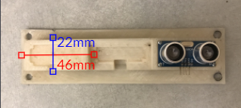

Fig. 3.14. Ultrasonic Array

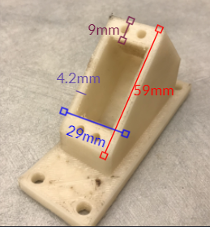

Fig. 3.15. First Iteration of Propulsion System Bracket

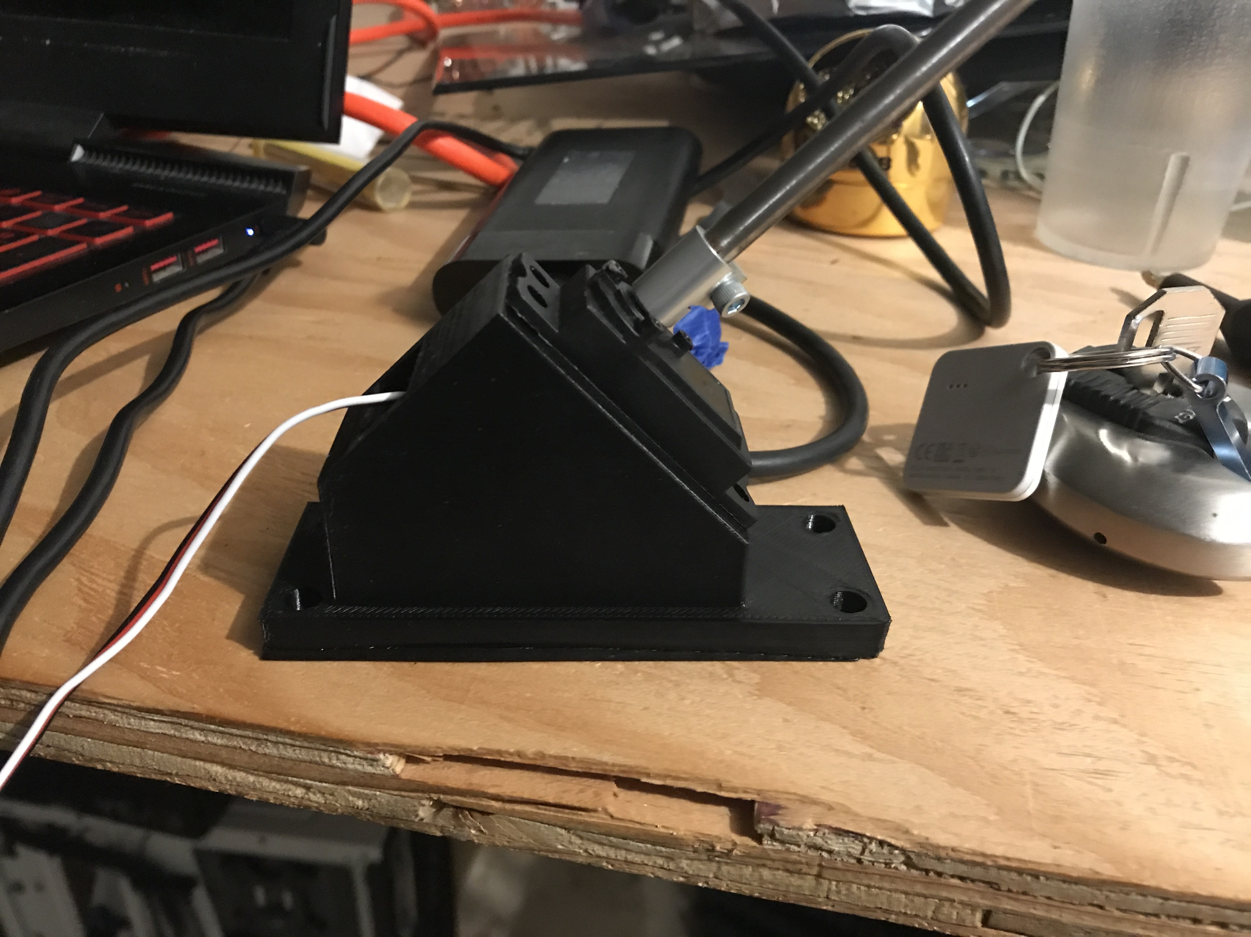

Fig. 3.16. Second Iteration of Propulsion System Bracket Holding Propulsion System

The results of the bracket measurements verified both the ultrasonic array subsystems ability to hold all three ultrasonic sensors and the propulsion subsystems ability to hold the servo. Additionally the servo coupler was successfully able to hold the shaft with the motor mounting block and motor attached to the servo, verifying the manufacturability of the propulsion subsystem. The dimensional accuracy of all the 3D printed parts verified STR 11.1.0, 3D printing.

3.3.2 Gondola

The next subsystem to be verified was the gondola. First, similar to the ultrasonic array and propulsion subsystems measurements were taken with a ruler and calipers to see that it met dimensional accuracy. Both the payload bay and housing basket were mesure to meet dimensional specifications shown in figure 3.17. During the barones first flight test the gondola was successfully able to hold a majority of the electrical system as intended further verifying its dimensions. The dimensional accuracy of the gondola further verified STR 11.1.0, 3D printing. Certain parts were not included in this test as they were not ready to be implemented into the system yet.

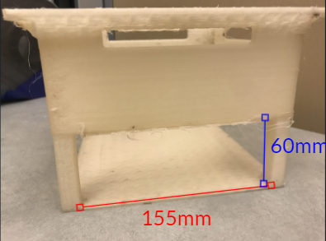

Fig. 3.17. Printed Gondola with Payload Bay Dimensions

Additionally, to verify the gondola, a heat analysis was performed in Solidworks to verify that the electronic components enclosed within the gondola did not break their maximum operating temperature. The results of the heat analysis showed a worst case maximum steady state temperature of 353° K or 80°C figure 3.18, below the maximum operating temperature of 100°C that most of the electronics on the board had. This heat analysis served as verification that the gondola could successfully house the electronics in its enclosed basket without the system overheating.

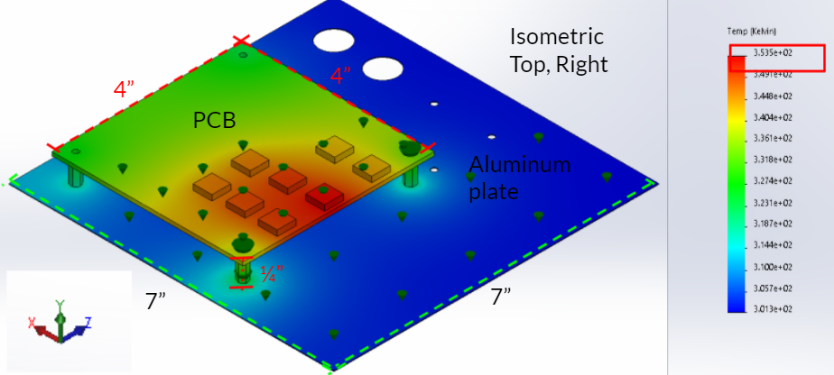

Fig. 3.18. Heat Analysis Test in Solidworks

3.3.3 Envelope and Lift Bag

The envelope and lift bag was the hardest subsystem to verify. To test the accuracy of its shape as well as usability to hold the propulsion system and ultrasonic array taut when inflated. Multiple inflation tests were performed with the procedure in figure 3.19 to verify it.

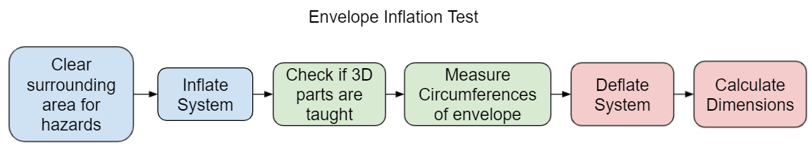

Fig. 3.19. Procedure Flow Chart of Inflation Test

The dimensional results of the test revealed that the shape of the envelope was not correct. We believe this to be due to two factors. First, the errors in sewing resulted in an incorrect shape, and secondly, the stitching was not successfully able to force the balloon into an elliptical shape, since oftentimes in testing the stitching would begin to break rather than the balloon being forced down into the correct shape. Seven iterations of the test were done with the envelope patched in various ways, with the results of significant versions shown in table 3.1. V7 which was the best and final version is pictured in figure 3.20. Although the envelope was able to show some improvement in shape across multiple versions, we believe that a new envelope would have to be made from scratch in order to meet the dimensional requirements. In its current form the envelope will create 44N of drag in a 20MPH airspeed and will not be able to meet STR 2.0.0, Drone Speed. Additionally the failure to meet the dimensional specifications within 5% caused STR 11.3.0, Envelope, to fail.

Table 3.1.

Results of Inflation Test on Significant Versions.

| Version | Circumferences | Diameters |
| --- | --- | --- |
| Goal | 255” & 339” | 108x108x40” |
| V1 | 284” & 309” | 98.4x98.4x81.7” |
| V5 | 269” & 308” | 98x98x71.1” |
| V7 | 276” & 322” | 102x102x70” |

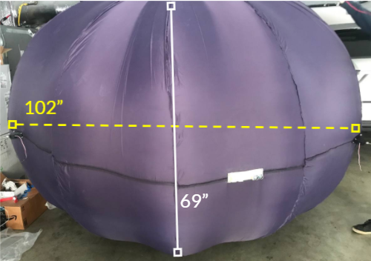

Fig.3.20. Inflated Envelope V7.

The inflation tests also checked to see if the brackets were successfully able to be attached to the envelope. Since the shape of the envelope was fabricated incorrectly the volume was estimated to be close to 6m3 rather than the intended 4m3 . In order to solve this problem air could be added before the helium so that the correct buoyant force was created while still filling the envelope until taut. In the first attempt to inflate the lift bag with the mounting plates and brackets attached. The lift bag was punctured when connecting with a sharp edge of one of the brackets. In order to fix this bubble wrap was applied to the inside mounting plate on the envelope and this was found to fix the puncturing problem found in the first test. Another issue found was that one of the propulsion system brackets was not correctly held taut, even when fully inflated; this is shown in figure 3.21. This slack on the propulsion system was believed to have caused more fabrication errors causing an area of the envelope to have excess material so that even when fully inflated the section pictured in figure 3.21 was not held taut like the other 3 propulsion systems.

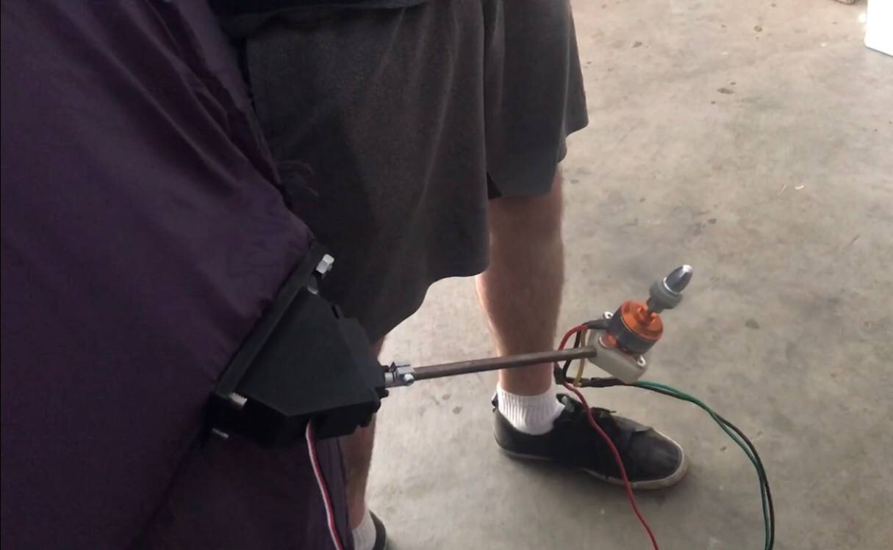

Fig.3.21. Propulsion System With Slack.

It was shown in inflation tests that when fully inflated three of the four propulsion systems as well as the ultrasonic array were held taut, an example of a taut propulsion system can be seen in figure 3.22. The ability to attach all subsystems together was also verified during an initial flight test as seen in figure 3.23. For more information about the flight test see Chapter 9.

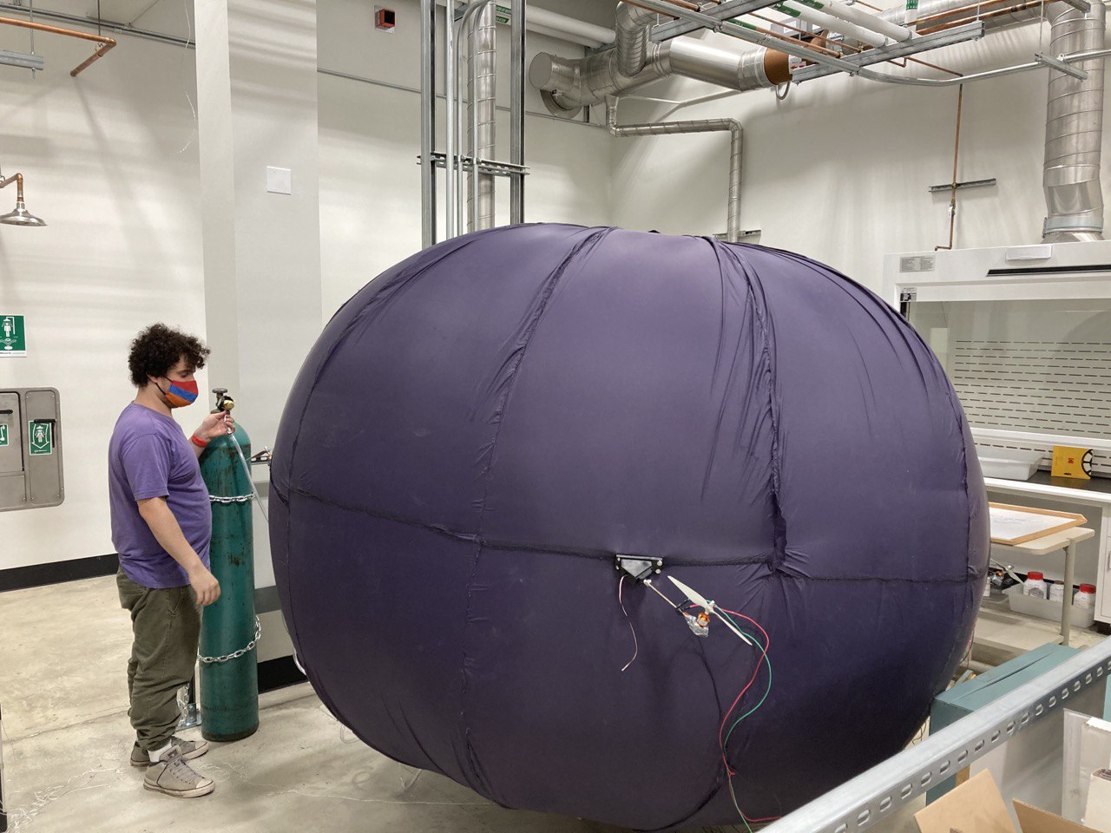

Fig.3.22. Propulsion System Held Taut During Inflation

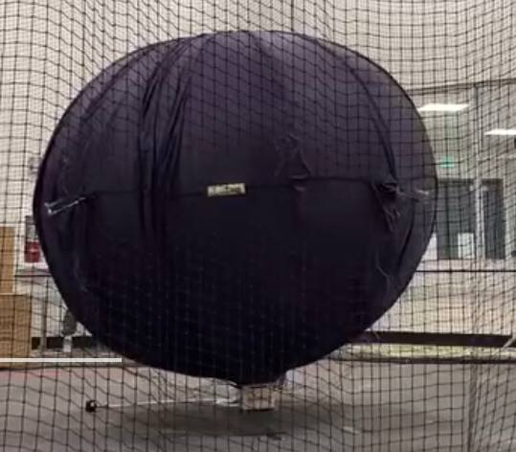

Fig.3.23. Full system assembled during first flight test.

## 3.4 Conclusion

After designing the various parts of the mechanical systems of The Barone, based on the technical requirements, Fabrication was carried out on all parts of the mechanical system. Then verification of these mechanical subsystems was carried out. The verification found the ultrasonic array, propulsion system, and gondola all meet their required dimensional specifications. This verified STR 11.1.0, 3D printing. The verification process of the envelope found that the envelope shape was not met, with the envelope being far too tall. Since the error in the envelope dimensions was greater than 5% STR 11.3.0, Envelope, failed to be met. The failure of the envelope to meet specification increased the drag our system experienced making it able to meet STR 2.0.0, Drone Speed.

# 

# Chapter Bibliography

We do have a full bibliography that should absolutely be updated with all content here. The point of the chapter bibliography is to help keep track of citations in the chapter since the numbering may change in the full bibliography with changes and additions. This way will isolate the sources in this section so you can cite here without having to worry about it, and can use a simple find and replace on your citations to update the new numbering when we combine everything in the final report.

[18] Peterson, Dave. “Dave Peterson.” *The Math Doctors*, 17 Feb. 2020, www.themathdoctors.org/making-a-sphere-from-flat-material/.